Liberty County Character Sheet

Liberty County is primarily a coastal county of 302,412 people. There are ten incorporated communities in the county: Central City, Apple Valley, Bayport, Blue Water, Deep River, Fisherville, Gold Mine (part of the Roaring River Indian Community), Harvest Junction, Jasper, and Kingston.

Contents

Liberty County Map 2

Roaring River Tribal Community (RRTC) 3

Hospitals in Liberty County 4

Public Health Department Information 4

County Fairgrounds 5

Liberty County Morgue Facilities 6

Senior Citizen Facilities 6

Nursing Homes 7

Ice Suppliers 8

# Liberty County Map



# Roaring River Tribal Community (RRTC)

|  |  |  |  |  |  |  |
| --- | --- | --- | --- | --- | --- | --- |
|  | |  | | --- | | RRTC has a population of 7,375 and is situated in the State of Columbia. It covers an area of about 1,200 square miles. It spans four counties: Liberty, Green, Kane, and Mineral. There are approximately 5,000 enrolled members living within the exterior boundaries of the reservation. The population remains fairly constant throughout the year with no seasonal shifts. The rest of the population (2,375) within the Tribal community is non-Tribal members who provide goods and services within the tribal area. | | |  |  |  | | --- | --- | --- | | |  | | --- | | Example Map of fictitious Roaring River Tribal Community showing Lakes; Airports; Interstates; State Routes; Rivers/Creeks; Railroads; Parks; County Boundaries. | | *Figure 2.2. Roaring River Tribal Community Map* | | | |

# Hospitals in Liberty County

|  |  |  |  |  |  |  |  |  |  |  |  |  |  |  |  |  |  |  |  |  |  |  |  |  |  |  |  |  |  |  |  |  |  |  |  |  |  |  |  |
| --- | --- | --- | --- | --- | --- | --- | --- | --- | --- | --- | --- | --- | --- | --- | --- | --- | --- | --- | --- | --- | --- | --- | --- | --- | --- | --- | --- | --- | --- | --- | --- | --- | --- | --- | --- | --- | --- | --- | --- |
|  | |  |  |  |  |  |  |  |  |  |  |  |  |  |  |  |  |  |  |  |  |  |  |  |  |  |  |  |  |  |  |  |  |  |  |  |  |  | | --- | --- | --- | --- | --- | --- | --- | --- | --- | --- | --- | --- | --- | --- | --- | --- | --- | --- | --- | --- | --- | --- | --- | --- | --- | --- | --- | --- | --- | --- | --- | --- | --- | --- | --- | --- | --- | | |  |  |  |  | | --- | --- | --- | --- | | **Hospital** | **Address** | **Location** | **Beds** | | Central City Hospital | D & 31st Streets | Central City | 360 | | Columbia Veterans Hospital | J & 7th Streets | Central City | 100 | | Faith Hospital | S & 14th Streets | Central City | 110 | | Levine Hospital | MM & 17th Streets | Central City | 43 | | Bayport Clinic | 5th Ave & Bay Blvd | Bayport | 10 | | Noble General Hospital | S & 1st Streets | Fisherville | 100 | | Harvest Junction Community Hospital | C & 3rd Streets | Harvest Junction | 100 | | Kingston Regional Medical Facility | P & 18th Streets | Kingston | 100 | | | Table 2.32. Hospital Locations | |

# Public Health Department Information

**Liberty County Public Health Department (LCPHD)**

|  |  |  |
| --- | --- | --- |
|  | |  | | --- | | LCPHD is located at the Nelson Center, FF and 11th Streets, Central City. The department’s primary functions include environmental health, community health, family health, and disease prevention and control services. LCPHD maintains a satellite office at the Fisherville Public Health Office, S and 3rd Streets in Fisherville. The LCPHD Director, in addition to directing LCPHD, also has oversight over the Liberty County Emergency Medical Services (EMS) Coordinator (see Appendix G, EMS). The LCPHD organizational chart is below. LCPHD is a NIMS–compliant agency, and all staff are trained in ICS according to their work responsibilities. | |
|  | |  | | --- | | * See Appendix G, “Emergency Medical Services” | | |  |  |  | | --- | --- | --- | | |  | | --- | | Refer to the IG/SM content for the alt text description of this image. | | *Figure I.2. Liberty County Public Health Department (LCPHD) Organizational Chart* | | | |

# County Fairgrounds

The Liberty County Fairgrounds are centrally located within one mile of Interstate 107, just northwest of Central City. The indoor and outdoor facilities at the Liberty County Fairgrounds are available for rent and are utilized throughout most of the year. Trade fairs, craft shows, festivals, and the annual Liberty County fair and rodeo are hosted at the fairgrounds. The land area consists of 127 acres. On-site parking is available for 7,500 vehicles. Overnight RV parking is also available.

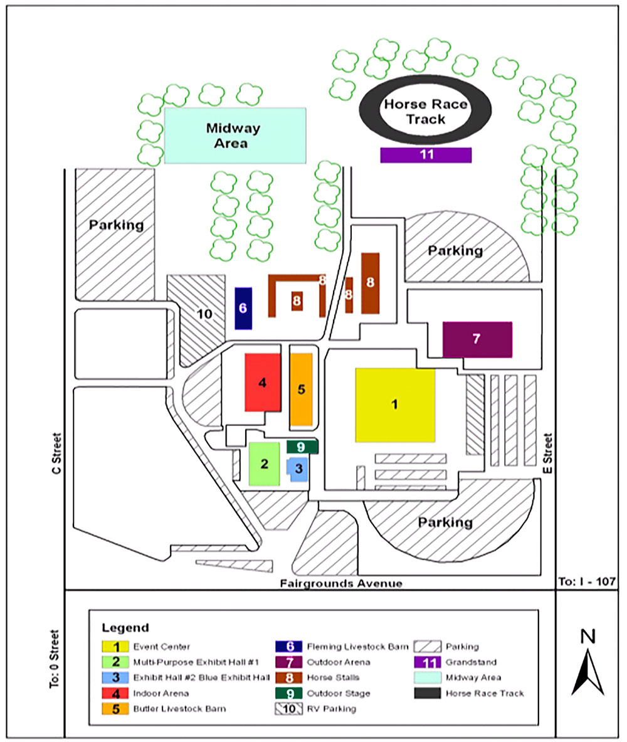

# Liberty County Morgue Facilities

Through cooperative agreements with area hospitals, the Liberty County Board of Supervisors has contracted Central City Hospital as the county morgue. Under normal conditions, hospital morgue facilities throughout the county can handle approximately 43 bodies.

|  |  |
| --- | --- |
|  | |
|  | |  |  |  |  |  |  |  |  |  |  |  |  |  |  |  |  |  |  |  |  |  |  |  |  |  |  |  |  |  | | --- | --- | --- | --- | --- | --- | --- | --- | --- | --- | --- | --- | --- | --- | --- | --- | --- | --- | --- | --- | --- | --- | --- | --- | --- | --- | --- | --- | --- | | |  |  |  |  | | --- | --- | --- | --- | | **Name** | **Address** | **Location** | **Capacity** | | Central City Hospital | D & 31st Streets | Central City | 12 | | Columbia Veterans Hospital | J & 7th Streets | Central City | 10 | | Faith Hospital | S & 14th Streets | Central City | 9 | | Noble General Hospital | S & 1st Streets | Fisherville | 6 | | Harvest Junction Community Hospital | C & 3rd Streets | Harvest Junction | 6 | |  |  | Total | 43 | | | Table H.37. Liberty County Hospitals Morgue Capacity | | |

# Senior Citizen Facilities

|  |  |  |  |  |
| --- | --- | --- | --- | --- |
| **Facility** | **Address** | **Location** | **Eligibility** | **Capacity** |
| Adams House | JJ & 11th Streets | Central City | Persons 62 years of age and older or disabled adults capable of independent living who receive an annual income of less than $20,000. | 300 apartment units in a 12-story building. 10 percent of the units have some modifications for disabled persons. |
| Highland Park | K &10th Streets | Central City | Persons 62 years of age and older. | 400 apartment units in a 17-story building. |
| Pepper Garden | W & 38th Streets | Central City | Persons 62 years of age and older or disabled adults who are able to care for themselves. | 210 apartment units in an eight-story building. All units are reportedly accessible to persons in wheelchairs. |
| Wood Hills Center | O & 30th Streets | Central City | Persons 62 years of age or older or disabled adults who are able to care for themselves. | 235 apartment units in a seven-story building. 12 units are accessible to persons in wheelchairs and have some modifications for disabled persons. |
| Ocean Front Plaza | Beach Blvd & 4th Ave | Bayport | Persons 62 years of age or older or disabled adults. | 200 apartment units in an eight-story building. Fifty percent of the units have modifications for disabled adults. |
| Willow Manor | F & 8th Streets | Deep River | Persons 62 years of age and older or disabled adults who are able to care for themselves. | 200 apartment units in an eight-story building. All units are reportedly accessible to persons in wheelchairs. |
| Downs House | AA & 9th Streets | Fisherville | Persons 62 years of age and older. | 300 apartment units in a 12-story building. |
| Roundup Park | C & 6th Streets | Harvest Junction | Persons 62 years of age and older or disabled adults who are able to care for themselves. | 200 apartment units in an eight-story building. All units are reportedly accessible to persons in wheelchairs. |
| Billboard Plaza | E & 11th Streets | Kingston | Persons 62 years of age and older or disabled adults. | 250 apartment units in a ten-story building. Fifty percent of the units have modifications for disabled persons. |

Table O.21. Senior Citizen Facilities

# Nursing Homes

|  |  |  |  |
| --- | --- | --- | --- |
| **Nursing Home** | **Address** | **Location** | **Average Patient Load** |
| Columbia | D & 11th Streets | Central City | 150 |
| Garden Run | T & 35th Streets | Central City | 250 |
| Green | MM & 27th Streets | Central City | 100 |
| Happy Times | N & 1st Streets | Central City | 100 |
| Hill Top | J & 3rd Streets | Central City | 250 |
| Liberty | S & 29th Streets | Central City | 150 |
| Lower Allen | G & 23rd Streets | Central City | 250 |
| Riverside | EE & 29th Streets | Central City | 200 |
| Gilmore | Bay Blvd & 10th Ave | Bayport | 100 |
| Oceanside | Ocean Blvd & 7th Ave | Bayport | 175 |
| Sunshine | C & 11th Streets | Deep River | 150 |
| Turkey Hill | AA & 14th Streets | Fisherville | 100 |
| Harvest Junction | F & 12th Streets | Harvest Junction | 100 |
| Kingston Center | B & 3rd Streets | Kingston | 150 |

Table O.22. Nursing Home Facilities

# Ice Suppliers

Bulk ice supplies have been identified as a resource that will be needed during an emergency. The following table identifies the entities that provide these services.

|  |  |  |  |
| --- | --- | --- | --- |
| **Name** | **Address** | **Location** | **Daily Tonnage/ Capacity** |
| Central City Ice Wholesalers | A & 11th Streets | Central City | 20 T/250 T |
| D Street Ice Wholesalers* | D & 8th Streets | Central City | 20 T/250 T |
| Central City Ice Wholesalers** | Q & 20th Streets | Central City | 20 T/250 T |
| Columbia Ice Wholesalers | Z & 3rd Streets | Central City | 20 T/250 T |